2020 Florida Emergency
Preparedness Association
Annual Meeting and Work Session


February 3 – 7, 2020
Hilton Daytona Beach Oceanfront Resort
Daytona Beach, Florida

Tradeshow
February 5-6, 2020

Please mail or email the registration form and preferred booth location to:

Diana Wright,
Exhibit/Sponsorship Coordinator
1744 River Birch Hollow
Tallahassee, FL 32308
Telephone: 850-508-2473
E-mail: dwright@nettally.com

HOTEL RESERVATION
DEADLINE
January 11, 2020

Hilton Daytona Beach Oceanfront Resort
100 North Atlantic Avenue
Daytona Beach, FL 32118
Telephone: 1-866-536-8477 or Direct 386-254-8200

Annual Meeting Room Rate: $145.00 Single/Double
Be sure to mention Florida Emergency Preparedness Association
to receive the Annual Meeting Rate

EXHIBITOR INFORMATION

Exhibitor Fee:
Includes 2 FULL ANNUAL MEETING Registrations, Breaks, Lunch and Receptions
$1,500 – Corner Booth
$1,400 – Inline Booth

Dimensions:
Exhibits will measure 10 x10. Included in the booth fee are:
• Draped 8’ back wall
• Draped 3’ side walls
• One six-foot draped table
• 2 chairs
• Wastebasket
• 7” x 4” Identification sign

EXHIBIT SERVICE MANUAL:
A service manual will be sent upon receiving your exhibit registration. There will be forms for electrical, internet, etc., as well as shipping information. Exhibits are assigned on a first come, first choice basis.

Note: The exhibitor assumes the entire responsibility and liability for losses, and claims arising out of exhibitor’s activities on the Hotel premises and will indemnify, defend and hold harmless the FEPA, the Hilton Daytona Beach Oceanfront Resort its agents, servants and employees from any and all such losses, damages and claims.

EXHIBITOR SCHEDULE

Set-Up Date and TIMEs:
Tuesday, February 4, 2020
12:00 p.m. - 5:00 p.m.

SHOW HOURS:
Wednesday, February 5, 2020
9:30 a.m. – 4:00 p.m.
President’s Welcome Reception – 5:30 p.m. -6:30 p.m.

Thursday, February 6, 2020
8:00 am – 10:30 am

Dismantle Date and Times:
Thursday, February 6, 2020 - 10:30 a.m. – 12:00 noon

PLEASE SEE THE FEPA WEB SITE FOR AN ADDITIONAL OPPORTUNITY TO SUPPORT THE ASSOCIATION.
CORPORATE MEMBERSHIPS ARE AVAILABLE AND INCLUDE A VARIETY OF AMMENITIES
www.fepa.org

FEPA 2020 ANNUAL MEETING
EXHIBIT HALL FLOORPLAN AND BOOTH LOCATIONS

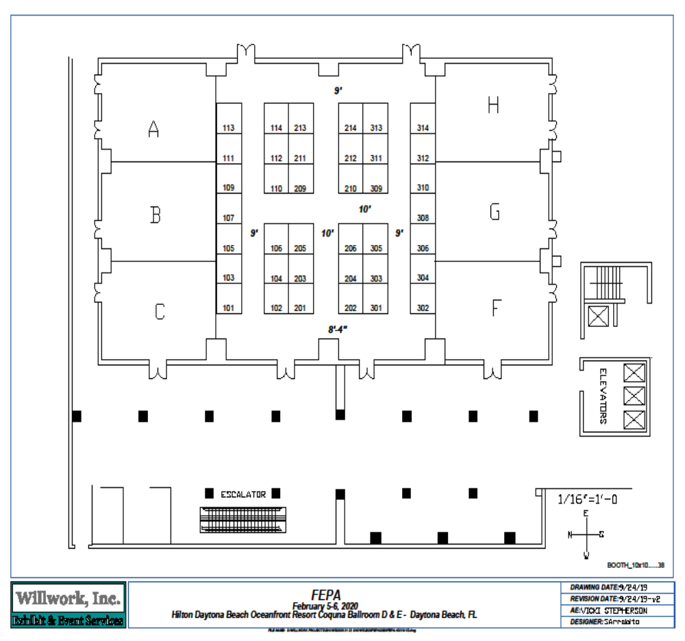

Exhibitor Registration

2020 Florida Emergency Preparedness Association
Annual Meeting and Work Session
Exhibit Hall Open: February 5-6, 2020
Hilton Daytona Beach Oceanfront Resort

Company__________________________________________ Assigned Booth________

Contact Person (Person handling paperwork) ___________________________________________________________

Onsite Contact Person: Name: ______________________________________________

Onsite Contact Person: Cell Phone: _______________________________

Address_________________________________________________________________________

City________________________________ ST _________ Zip ___________________

Phone _____________________________ Fax __________________________
E-mail ___________________________________________________________________________

BOOTH STAFF: (Booth rental includes 2 annual meeting registrations)
Please submit a $250.00 fee for each additional staff person

(Print name as it should appear on name tag):

Representative 1: ______________________________________________________________

Representative 2: ______________________________________________________________

Additional Staff at $250.00 each:

Representative 3: ______________________________________________________________

Representative 4: ______________________________________________________________

Representative 5: ______________________________________________________________

Preferred Booth Space(s): 1st Choice_______ 2nd Choice ________ 3rd Choice __________

Any firms you prefer to be near or separated from: _______________________________________

****Cancellation: There will be a $100.00 cancellation fee for any exhibitor
that cancels 60 days out (December 3, 2019) from the annual meeting.
NO REFUNDS will be given 30 days (January 4, 2020) out from annual meeting
date of February 3, 2020.
All cancellations must be submitted in writing to Diana Wright at dwright@nettally.com

No registration can be accepted without payment.

PLEASE MAKE CHECKS PAYABLE TO: FEPA • FEID #59-2389989

PAYMENT METHOD: Check # ____________

Credit Card Type: AMX MC VISA

Credit Card Number _______________________________________________________

Expiration Date: _______ Amount to be processed $ _________ Security Code ________________

Cardholder’s name (print) _____________________________________________________________

Billing Address of Cardholder _________________________________________________________

City_______________________________________ State ___________ Zip ___________________

Email Address of Cardholder __________________________________________________________

Telephone Number of Cardholder ________________________________________

Cardholder’s Signature__________________________________________________________

RETURN FORM TO:

Diana Wright, Exhibit/Sponsorship Coordinator
Conference Management Solutions
1744 River Birch Hollow, Tallahassee, FL 32308
Telephone: (850) 508-2473
Email: dwright@nettally.com

FEPA Annual Meeting Advertising Rates

Annual Meeting Program size 8½ x 11

Size Dimension Price
Color
Full Page Ad 8.375” wide by 10.875” tall $750
Half Page Ad (vertical) 3.375” wide by 9.5” tall $550
Half Page Ad (horizontal) 7” wide by 4.625” tall $550
Quarter Page Ad 3.375” wide by 4.625” tall $400
Business Card Ad 3.375” wide by 2” tall $300

FEPA Newsletter Advertising Rates
Newsletter size 8½ x 11 Published February, June, August and November

Deadline For Submittal Of Artwork Is:
January 10, May 10, July 10, October 10

Size Dimension Color
Full Page Ad 8.375” wide by 10.875” tall $600
Half Page Ad (vertical) 3.375” wide by 9.5” tall $450
Half Page Ad (horizontal) 7” wide by 4.625” tall $450
Quarter Page Ad 3.375” wide by 4.625” tall $350

2020 FLORIDA EMERGENCY PREPAREDNESS ASSOCIATION
ANNUAL MEETING AND WORK SESSION

Contract for Advertising

Please specify:
Annual Meeting Program Only: _____
FEPA Newsletter Only: _____
Both: _____

Company/Agency ________________________________________ Date _____________

Company Representative ______________________________________________________

Contact Person ______________________________________________________________

Address ___________________________________________________________________

City ________________________________ State ________ Zip ______________________

Phone ___________________________ Fax ___________________________________

Email _____________________________________________________________________

Authorized Personnel Signature ________________________________________________

Return form to:
Eve Rainey, Executive Director, FEPA
400 Capital Circle SE, Suite 18-263
Tallahassee, FL 32301
Email: erainey@fepa.org • (850) 274-1835

2020 FLORIDA EMERGENCY PREPAREDNESS ASSOCIATION
ANNUAL MEETING AND WORK SESSION

Sponsorship Opportunities

FEPA LUNCHEON (WEDNESDAY) $15,000
February 5, 2020

Closing Session Breakfast (Friday)
February 7, 2020 - 8:00 a.m. $ 8,000

MORNING COFFEE BREAKS
10:00 a.m. – 10:30 a.m.
Monday, February 3, 2020 $ 2,000
Tuesday, February 4, 2020 $ 2,000
Wednesday, February 5, 2020 (Exhibit Hall) $ 2,000
Thursday, February 6, 2020 (Exhibit Hall) $ 2,000

AFTERNOON BREAKS
3:00 p.m. – 3:30 p.m.
Monday, February 3, 2020 $ 3,500
Tuesday, February 4, 2020 $ 3,500
Wednesday, February 5, 2020 (Exhibit Hall) $ 3,500
Thursday, February 6, 2020 $ 3,500

Sponsor the Breaks an Entire Day and Save! $ 5,000

Reception:

Officers Reception $ 10,000
Thursday, February 6, 2020

For additional information about sponsorship opportunities, please contact
Diana Wright, Meeting Manger at dwright@nettally.com or by telephone at
850-508-2473.

2020 Contract for Sponsorship

EVENT: _______________________________________________ COST: $________________

DATE OF EVENT: _____________________

Company/Agency ______________________________________________________________
Company Representative: ________________________________________________________

Contact Person ________________________________________________________________

Address ______________________________________________________________________

City _____________________________________________ State ________ Zip _________

Telephone _____________________________ Fax _______________________________

Email ________________________________________________________________________

Authorized Personnel Signature: ___________________________________________________

PAYMENT:
Check # ___________ Credit Card (circle one: American Express MasterCard Visa)
Please make checks payable to: FEPA • Federal I.D. 59-2389989

Credit Card Number _______________________________________________________________

Exp. _______________ Security Code _________________________

Print Name of Card Holder (print) ____________________________________________________

Billing Address of cardholder ________________________________________________________

City ___________________________________ State ______________ Zip ___________________

Email Address of cardholder _________________________________________________________

Cardholder Telephone Number _______________________________________________________

Signature ________________________________________________________________________

Please return form to: Diana Wright, Annual Meeting Manager
FEPA c/o Conference Management Solutions
1744 River Birch Hollow, Tallahassee, FL 32308
Email: dwright@nettally.com • (850) 508-2473

